## Introductory problem:

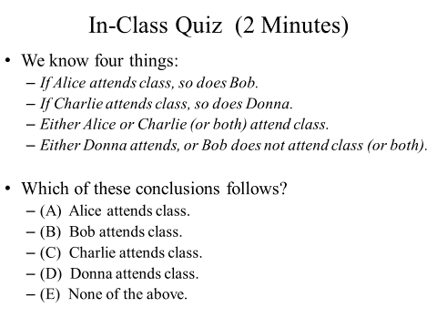

Inference and Proofs (1.6 & 1.7)

As is commonly the case in mathematics, it is often best to start with some definitions.

* An **argument** for a statement S is a sequence of statements ending with S.
* We call S the **conclusion** and all the other statements the **premises**.
* The argument is **valid** if, whenever all the premises are true, the conclusion is also true.
  + Note: A valid argument with false premises could lead to a false conclusion.
* **Proofs** are **valid arguments** that establish the truth of mathematical statements.

Now the definitions here are a bit screwy in that we are saying that an argument doesn’t involve anything other than stating the premises and the conclusion without explanation. In general, we’ll be working with a “deductive argument” where a third thing is added: intermediate steps that lead us from the premises to the conclusion.

### Sample argument

* **Premises**:
  + “If you’re a CS major then you must take EECS 203 before graduating.”
  + “You’re a CS major.”
* **Conclusion**:
  + (Therefore,) “You must take EECS 203 before graduating.”

This is a valid argument. It is based on the tautology ((p → q) ∧ p) → q. That is, if p implies q and we know p is true, q must be true.

# Rules of Inference (1.6)

There are of course any number of similar tautologies that could be used in arguments. There are a handful of relatively simple argument forms, called **rules of inference**. This one we used in the sample argument is called “Modus ponens” (the mode that affirms).



One thing you will want to do is learn the more common rules of inference. I’m only going to ask you to memorize a handful of the rules of inference, though you need to be able to use any of them. The entry above and the table on the next page is taken from page 72 of the text. You are expected to have the following rules memorized by name for quizzes and exams (of course you get notes on exams, and no, this won’t be on tomorrow’s quiz).

* Modus ponens
* Modus tollens
* Hypothetical syllogism
* Simplification
* Addition



(Brief aside: we will often see the “premises” go by a number of names including hypothesis and supposition. When using the rules of inference they are the same thing. But “premise” implies you are sure about it, while hypothesis and supposition implies that you are less certain.)

Now let’s see how to form a deductive argument. Let’s consider the following argument:

* Premises :

1. “If Jo has a bacterial infection, she will take antibiotics.”
2. “Jo gets a stomach ache when and only when she takes antibiotics and doesn’t eat yogurt.”
3. “Jo has a bacterial infection.”
4. “Jo doesn’t eat yogurt.”

B: “Jo has a bacterial infection.”

A: “Jo takes antibiotics.”

S: “Jo gets a stomach ache.”

Y: “Jo eats yogurt.”

* Conclusion:
  + “Jo gets a stomach ache.”

**Translation to propositions**

Let’s write these premises as propositions.

1. _______________________________
2. _______________________________
3. _______________________________
4. _______________________________

And the conclusion is:

* ____________________________

**Deductive argument**

Premises:

1. _______________________________
2. _______________________________
3. _______________________________
4. _______________________________

Intermediate steps (fill in the reasoning):

1. A _________________________
2. (A ∧ ¬Y) _________________________
3. ((A ∧ ¬Y) → S) ∧ (S → (A ∧ ¬Y)) _________________________
4. (A ∧ ¬Y) → S _________________________

Conclusion (fill in the reasoning):

* ____________ _________________________

And now we have a deductive argument! It’s also fine to mix the three parts. Consider this example from the text where we are trying to conclude “t”. Don’t worry about the specific argument, I just want you to follow the format.

Here we’ve got the premises mixed with the intermediate steps and the conclusion. That is a common way to write out your deductive argument, though I prefer the other format.

### Another inference problem

Work out a deductive argument for concluding ¬q→s with the premises p→ q, ¬p→ r, and r→ s. (Hint: Contrapositive is helpful here, also this is from page 74)

### Yet another inference problem

**Defined propositions:**

**U = “I understand the material”**

**A = “I get good grades”**

**J = “I will get the job”**

**G = “I am a genius”**

**C = “I go to class”**

Premises:

* If you understand the material, you will get good grades.
* If you get good grades, you’ll get the job.
* You either understand the material or are a genius.
* If you are a genius, then you don’t go to class.
* You go to class.

Conclusion:

* Will you get the job?

## Rules of Inference for Quantified Statements

****The basic theme of these is that we can jump between a quantified statement (like ∃k (n=2k)) and a specific instance or back. These are trivial, but are oddly difficult to work with as there is an issue of scope that creeps in.

**Universal instantiation** says that we can assume that an arbitrary P(c) exists if we know something holds for all P(x).

**Universal generalization** says that if we know P(c) is true for an arbitrary c, it’s true for all c.

**Existential instantiation** tells us if P(x) is true for some value of x, there is a P(c) for which it is true.

And **Existential generalization** tells us that if P(c) is true for some c, it’s true for at least one case.

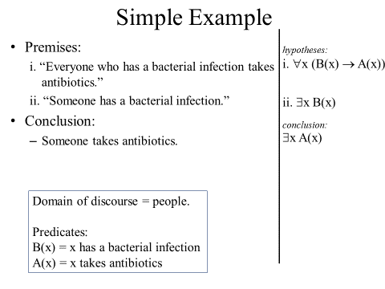

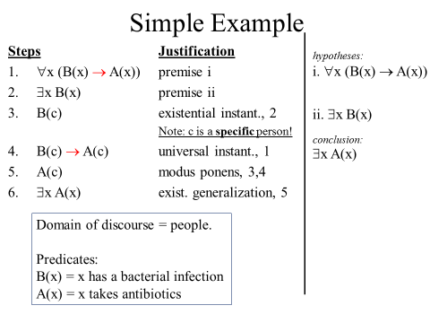

# Proofs! (1.7)

A good place to start on proofs is basic number theory, so let’s define some terms and get moving. Let’s assume our domain of discourse is the integers. Then:

* **Even(n)** : “n is an even number”. Even(n) short for ∃k (n=2k)
* **Odd(n)** : “n is an odd number”. Odd(n) short for ∃k (n=2k+1)

## Direct proofs.

A **direct proof** of a conditional statement p → q is constructed when the first step is the assumption that p is true; subsequent steps are constructed using rules of inference, with the final step showing that q must also be true.

1. Give a direct proof of the theorem “If *n* is an odd integer, then *n*2 is odd.”

Note, this could be phrased as ∀*nP ((n)* → *Q(n))*, where *P(n)* is “*n* is an odd integer” and *Q(n)* is “*n*2 is odd.” However by tradition the universal quantifiers are left out.

* 1. Assume n is odd.
  2. Thus ∃k (n=2k+1)
  3. For some k, n2=(2k+1)2
  4. (2k+1)2=4k2+4k+1
  5. 4k2+4k+1=2*(2k2+2k)+1
  6. By the definition of an odd number that is odd (it is one more than twice an integer)
  7. Thus if n is odd, n2 is odd.

You’ll notice that we didn’t really use much in the way of the rules of inference or anything else really. We just formed an argument from start to end. This is pretty typical for real-world proofs. In fact, the proof of this in the book (page 82) doesn’t even break the problem down into steps as we did above…

1. Use a direct proof to show that the sum of two odd integers is even.

## Indirect proofs

An indirect proof is when we don’t just start with premises and reach a conclusion.

### Proof by Contraposition

An extremely useful type of indirect proof is known as proof by contraposition. Proofs by contraposition make use of the fact that the conditional statement p → q is equivalent to its contrapositive, ￢q →￢p. This means that the conditional statement p → q can be proved by showing that its contrapositive,   
￢q →￢p, is true.

**Example**: Prove that if *n* is an integer and 3*n* + 2 is odd, then *n* is odd.

Try a direct proof first. We see that 3n+1=2k, but it’s not clear how that helps. So let’s try the contrapositive.

State the contrapositive in English: ___________________________________

Now use a direct proof of the contrapositive.

### Proof by contradiction

If you want to prove **p**. *Assume that* ***p*** *is false*, i.e., make ¬**p** a premise. Deduce a contradiction (F),

e.g., 1=0, N is both odd and even, etc.

Doing that shows that ¬**p**→F is true and so we can conclude **p**. (Can you see that ¬**p**→F ≡ **p**)?

The next example is one of my favorite proofs!

*Show that there are an infinite number of primes.* There are actually a few clean ways to do this, but a proof by contradiction is pretty straightforward.

* 1. Assume that there is a finite number of primes.
  2. That means we can list them in order. p1, p2, …, pn. (p1 = 2, p2 = 3, p3=5, etc.)
  3. Let K=p1*p2*…*pn+1.
  4. It’s clear that no pi divides K (all will have a remainder of 1!)
  5. Hence K is prime. But K is larger than all the primes.
  6. Thus our initial assumption must be mistaken.

*Prove that √2 is irrational by giving a proof by contradiction.*

(Hint: if a number is rational, it can be represented by a/b where a and b are integers and have no common terms).

# Proof methods (but first introduction to number theory)

There are a number of things we can find proofs about. But one nice area to work with is number theory. We are going to cover number theory in a lot more detail starting at the end of next week. But let’s get some elementary school review done now and take a brief look at some more proofs methods/strategies. I’m not going to cover much of 1.8 in class, so it’s up to you to read it over. There is very little specifically new in that chapter, but there are lots of good examples.

## Division: it’s elementary (school)

The terminology of division is illustrated in the figure on the below. In addition to those terms, there are some others you should know:

* Informally, when we say “**a divides b**” we mean “when we divide b by a we get no remainder”.
* Formally: for integers a, b, we say   
   a | b := ∃c∈***Z*** (b = a*c)

**Quotient**

**Dividend**

**Remainder**

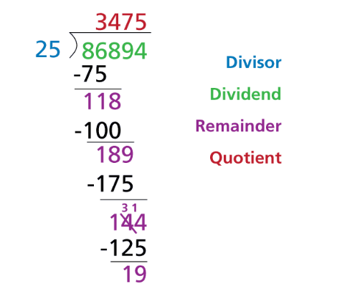

**Divisor**

### Questions

Which of the following are true (for this section, assume our domain of discourse is the integers unless otherwise stated).

* 13 | 52?
* 0 | 94?
* 94 | 0?
* ∀a∀b∀c (a | b) ∧ (b | c) 🡪 (a | c)
* If (a | b) ∧ (c | d)
  + Then (a + c) | (b + d)?
  + Then ac | (b + d)?
  + Then ac | bd?

And let’s try our hand at formal definition.

What does “p is a prime number” really mean?  
(Assume p > 1. And domain of discourse = the non-negative integers)

∀a [(a | p) 🡪 __________________________

# Wrapping up

We are now done with Chapter 1! The material from this chapter will show up throughout the rest of the class. There will be a lot more upside down As and backwards Es. And we’ll see a lot of proofs.

And let’s close with a hard inference example. It’s unlikely we’ll get to this example in class, but it’s a nice example of a tough problem involving quantifiers and inference rules.

