# composition-of-functions.jpgReview from last time

1. What can you say about the sets *A* and *B* if we know that
   1. *A* ∪ *B* = *A*?
   2. *A* − *B* = *A*?
   3. *A* − *B* = *B* − *A*?
2. Let f : B→C and g: A→B. (note, this was different/wrong in the notes handed out)
   1. If *f* and *g* are one-to-one, is f ◦ g also one-to-one?
   2. If *f* and *g* are onto, is *f ◦ g* also onto?
   3. If *g* and *f ◦ g* are onto, is f also onto?
3. Write a formal definition of what it means if function *f* from A→B is onto.

latex-image-1.pdf

1. Is it true that A ⊕ B ≡ B ⊕ A?

Start on Sequences and Summations (2.4)

A sequence is a function from a subset of the set of integers (usually either the set {0, 1, 2, . . .}

or the set {1, 2, 3, . . .}) to a set S. We use the notation an to denote the image of the integer n.

We call an a term of the sequence.

* Consider the sequence where an=2n. In that case, the sequence, starting with a1 is 2, 4, 6, 8, etc.
* Consider the sequence where an=. In that case, what is the sequence?

## Recurrence Relations

A recurrence relation expresses the value of an as a function of previous values. For example, the recurrence relation $a_{0}=0, a_{1}=1, a{}_{n}=a_{n-1}+a_{n-2}$ for $n≥2$ defines the *Fibonacci sequence*. That is 0, 1, 1, 2, 3, 5, 8, 13, 21, etc.

The *sequence* is the *solution* to the recurrence relation. Ideally we’d be able to find it in “closed form” or “closed formula” (that is where we could compute an­­ directly without finding an-1 first).

* Define the even integers (from lowest to highest) as a recurrence relation.
* Define the factorial function (n!) as a recurrence relation.

Recurrence relations hold a special place in computer science. It is often the case that we develop algorithms and then ask ourselves how efficient the algorithm is. And fairly commonly we find ourselves with algorithms where we split the problem into parts and then re-run the algorithm on the parts (recursive programs do this…). We will in fact spend a fair bit of time near the end of this term learning some general techniques for solving recurrence relations (one algorithm turns out to be nearly the same as solving differential equations).

## Summation of a sequence

Sometimes we want to know the sum of a sequence. So the sum of the first N elements (a1+a2+…+aN). We generally write that as $$\sum_{i=1}^{N}{a_{i}}$$

Consider the following summation of the sequence ½, ¼, etc.

$$\sum_{i=1}^{N}{\frac{1}{2^{i}}}$$

Can you find a closed-form solution to that? What is the value as N approaches infinity?

Find a closed-form solution for the sum of the sequence 1, 2, 3, etc.



## Questions

1. What is the value of $\sum_{i=0}^{5}{{\left(-2\right)}^{i}}$?
2. What is the closed form of the sum $\sum_{k=0}^{n}{a_{k+1}-a_{k}}$? (This is called a “telescoping series”)

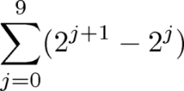

1. Find

## An example summation

Sometimes the telescoping sum trick can be useful where it doesn’t seem like it would be useful. Let’s attack the following summation in two different ways. $\sum_{k=0}^{n}{k(k+1)}$

**Answer one**: This is basically $k^{2}+k$ summed from 0 to n. By the associative/commutative properties of addition we can write this as $\sum_{k=0}^{n}{k(k+1)}= \sum_{k=0}^{n}{k^{2}+\sum_{k=0}^{n}{k}}$. We can start k at 1 rather than 0 (as k and k2 are both 0 when k is 0) and then just use the formulae above for the sum of k and k2.

*[With a bit of algebra, we can get the sum of k2 from 1 to n to be (1/3)n3 + (1/2)n2 + (1/6)n. So what is $\sum_{k=0}^{n}{k(k+1)}$?]*

**Answer two:** We can try to manipulate this into a telescoping sum. *Note: I’d have never ever come up with this, but it is cool.*

$$3k\left(k+1\right)=\left[3+k-k\right]k\left(k+1\right) \\ =\left[\left(k+2\right)-\left(k-1\right)\right]k\left(k+1\right)$$

$$=k\left(k+1\right)\left(k+2\right)-\left(k-1\right)k\left(k+1\right)$$

$=a_{k+1}-a_{k}$ when $a_{k}=\left(k-1\right)k(k+1)$

And thus we get:

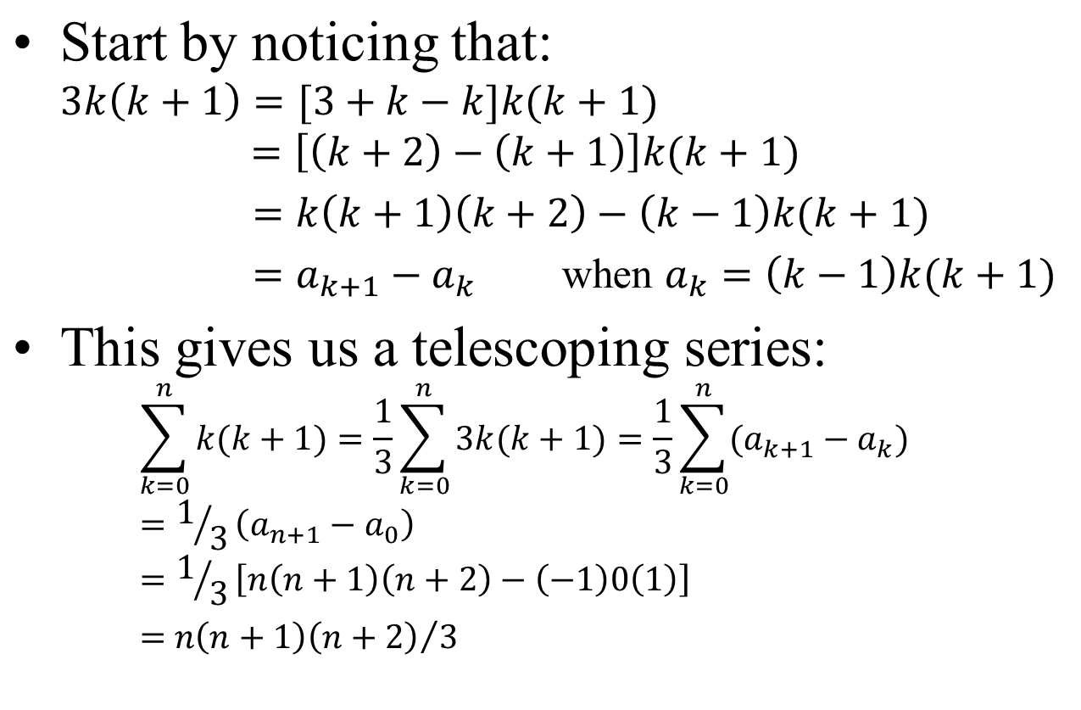

## And a very relevant series

Compound interest is important. If you start with a0 dollars with an interest rate of “r”, you get   
a1=(1+r)a0.

* What is a2 in terms of a1? _________________ in terms of a0? __________________
* What is an in terms of a0?__________________________

What would it look like if in addition, we saved d dollars a year (so a0=d and we add d dollars every year)?

Let k=1+r (so if the interest rate is 10%, r=0.1 and k=1.1).

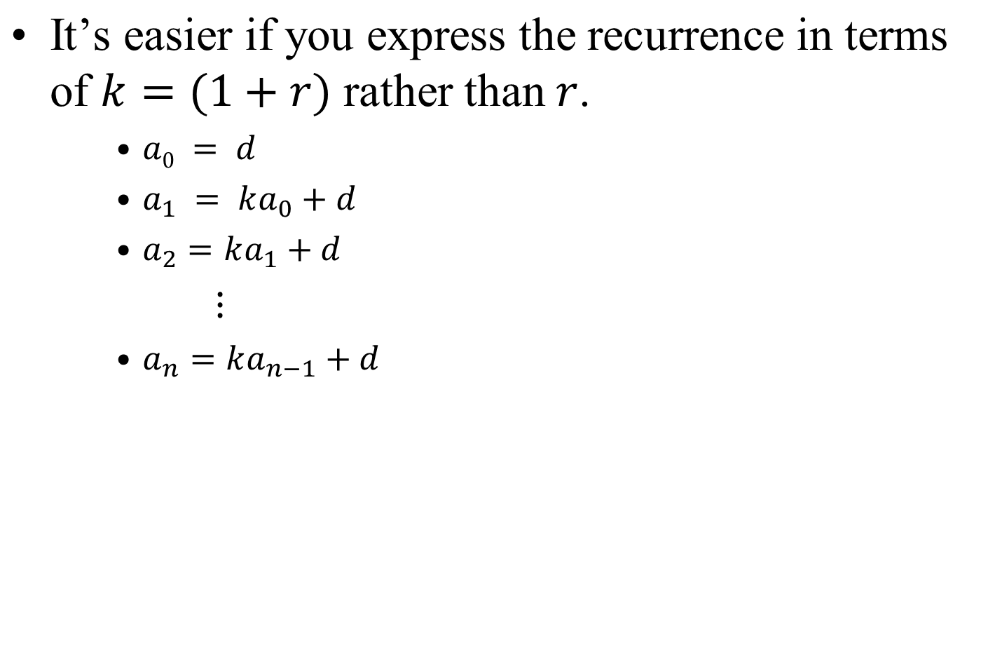

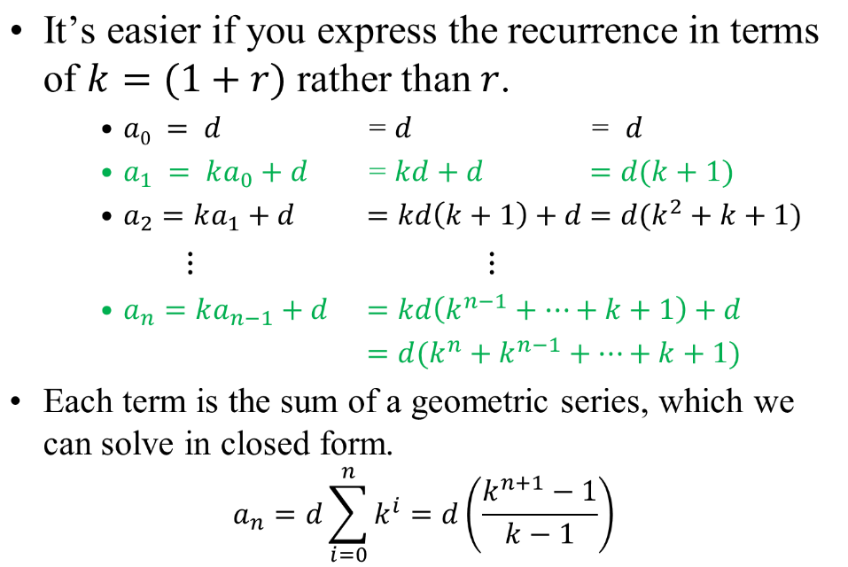

# Infinite Sets and Cardinality (2.5)

One interesting thing I’ve alluded to earlier is that the cardinality of sets isn’t always trivial. When dealing with finite sets, it’s generally pretty easy to figure out how many elements are in the set. But what about things like **Z**, **N**, **Q**, and **R**? Clearly they are all infinite, but are they the same infinity? Does that question even make sense?

Let’s start with some fairly obvious statements.

If $f:A→B is 1 to 1 then \left|A\right|≤\left|B\right|.$ If $f:A→B is 1 to 1 and onto then \left|A\right|=\left|B\right|.$

Now, let’s jump to the definition of a “countable” set. (Recall that a function that is 1 to 1 and onto is set to be a 1 to 1 correspondence or a bijection. Lots of jargon here)

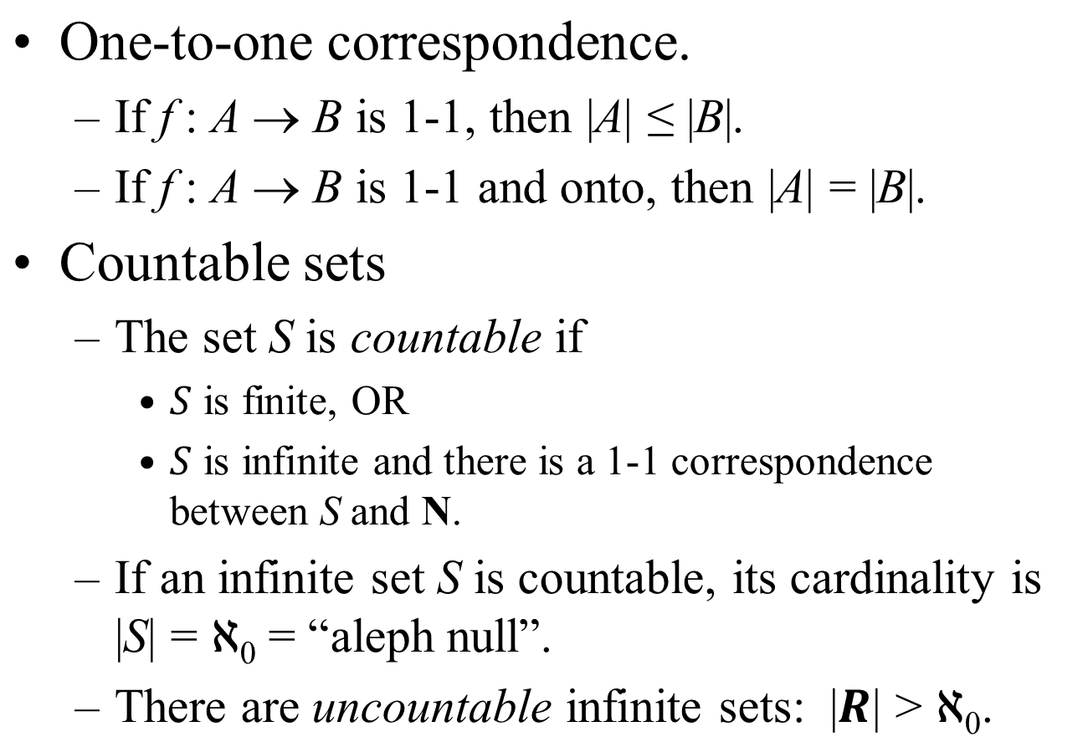Let’s show that the integers are countable. Can you find a bijection from **Z** to **N**?

Can you find an inverse of your function from N to Z? Do we know one must exist?

Now this should seem a bit strange. Clearly $Z⊂N$, but |Z|=|N|. With finite sets, if $A⊂B$ then cardinality A is always less than B.



Figure 1:There's always room for one more at Hilbert's Grand Hotel.

How does the above picture relate to our discussion?

Let’s consider the positive rational numbers (**Q+**). Can you show that *those* are countable? How does the figure below help?



How about **Q**?

OK, so how do we prove something *isn’t* countable? I mean it’s one thing to show that there *is* a bijection between two sets, but quite another to show that there isn’t one.

(Blank space for proof that the reals are not countable)

## Some results about cardinality.







Now prove that |(0,1)|=|(0,1]|.