Counting

We’ve been working on counting for the last two lectures. We’re going to continue on counting and probability for about 1.5 more lectures (including this one…) But first let’s do some review questions (we probably won’t do all of these in class)

1. How many ways are there to select a 1st, 2nd and 3rd prize winner from 50 people?
2. How many ways are there to select 3 “runners up” from 60 people?
3. How many 5 card poker hands are there (recall a standard deck has 52 cards)?
4. How many ways are there to select a poker hand that has a pair of aces and no other ace or other pair?
5. What is the probability of rolling a 5 or less (total) on 2 fair six-sided dice?

# Generalized Permutations and Combinations (6.5)

A bagel shop has 8 kinds of bagels. How many ways are there to buy a dozen bagels?



This is identical to asking how many solutions are there to the equation x1+x2+x3+x4+x5+x6+x7+x8 = 12. We can think of this as:

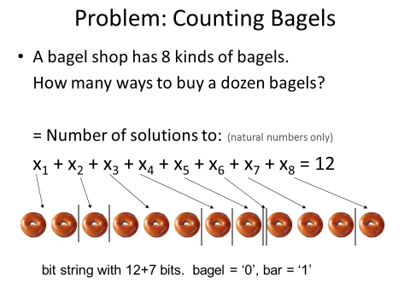

What we’ve really got is 7 bars and 12 bagels. We can think of this as a bit string with 19 bits where 7 of them need to be “1s” while the rest are “0s”.

## The Stars ‘n’ Bars Theorem

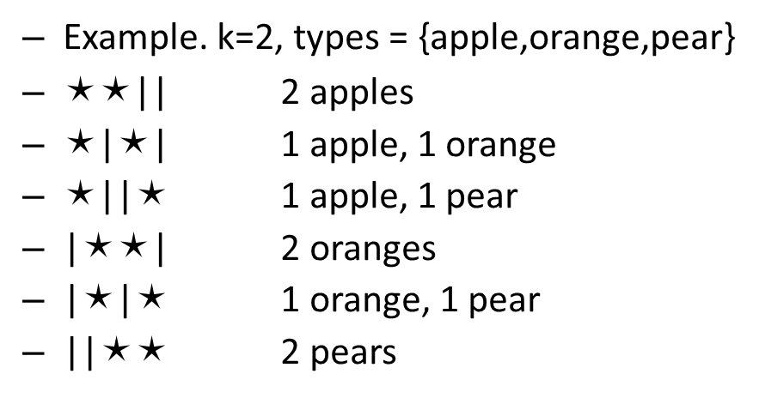The number of ways to choose k objects each of n   
  
different types (with repetition) is

You put a “star” for each object and one less bar than there are types. So how many ways can you select 2 fruits from 3 different types?

Now let’s see what happens when we start putting restrictions on the number we can pick. Let’s go back to selecting a dozen bagels out of 8 types.

* Say we are required to select at least one of each type. How many ways are there to do that?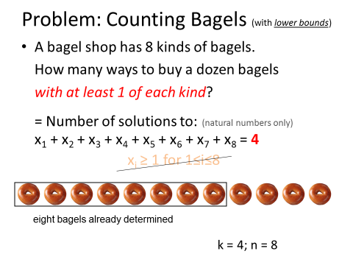  
  What is k? What is n?
* What if we need to select no more than 4 onion bagels and 2 poppy seed bagels?   
  (so $x_{1}≤4 and x_{2}≤2$). Probably the easiest way is to figure out how many combinations involve $x_{1}>4$ and how many involve $x_{2}>2$ and subtract those off. Of course we’d end up subtracting off some cases twice.

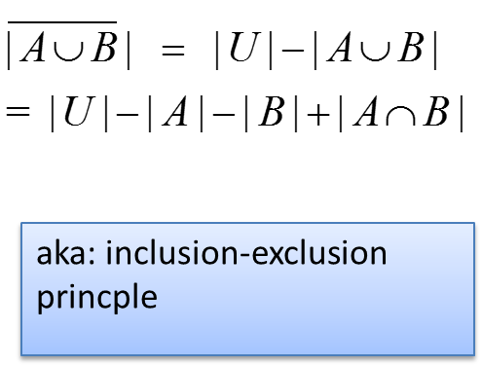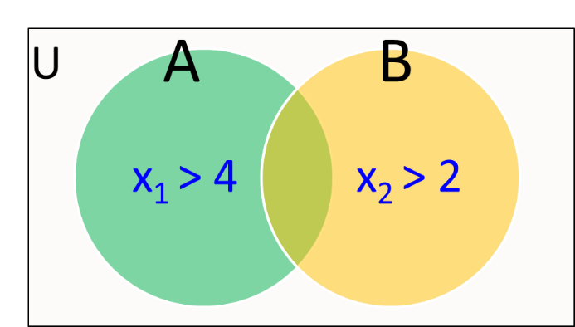

So what’s the answer?

* All Solutions? \_\_\_\_ stars, \_\_\_\_ bars.
* Solutions with x1>4? \_\_\_\_ stars, \_\_\_\_ bars.
* Solutions with x2>2? \_\_\_\_ stars, \_\_\_\_ bars.
* Solutions with x1>4 and x2>2? \_\_\_\_ stars, \_\_\_\_ bars.  
  Final answer?

## Permutations with repetition

Say a license plate can have 7 symbols, each either an (upper case) letter or a digit (0 to 9).

* How many license plates can there be?

Now say someone named MILLER wants to have a license plate with either their name or an anagram of their name (the letters kept the same but in any order). How many of those are there?

How many ways are there to rearrange the letters SUCCESS? We’ve got 3 S’s, 2 C’s, 1 U and 1 E. The S’s can be placed in C(7,3) different ways. Leaving C(4,2) ways for the Cs and C(2,1) for the U. That leaves only one choice C(1,1) for the E. You could do that in a different order, but you’d end up with the same number.





* So how many anagrams are there of MISSISSIPPI?

## Bonus question

* How many strings of six lowercase letters from the English alphabet contain the letters ***a*** and ***b*** in consecutive positions with ***a*** preceding ***b***, with all letters distinct?

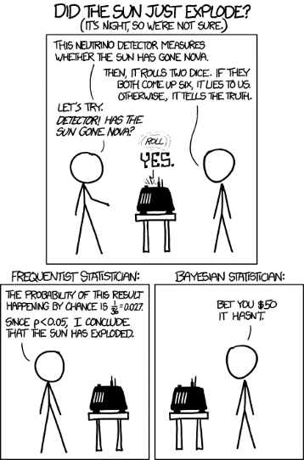Discrete Probability (Chap 6)

Some quick thoughts on probability:

1. Games of chance have been around for a long time.
   * We have evidence of gambling dice, in the form of bones of animals, used by humans thousands of years ago.
2. We didn’t have a real mathematics of probability until recently!
   * It wasn’t until the late 1600s that probability calculations and theory were developed in any serious way.
3. Probability is a philosophically difficult concept
   * How can we talk about the probability of an event that happens only once? (see comic)
   * What’s the probability that this lecture will be good?
4. Humans are really bad at probability
   * “I rolled a dice 4 times in a row, I got a 6 each time, so the next roll must definitely not turn up a 6”
   * There are studies showing that when asked to generate as random a string of 0s and 1s (without flipping coins or dice) it is generally fairly trivial to figure out which were actually generated randomly and which by a person trying to be random.

# Discrete Probability: Terminology

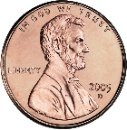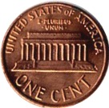

* **Experiment**: Procedure that yields an outcome
  + E.g., Tossing a coin three times
* **Outcome**: HHH in one trial, HTH in another trial, etc.
* **Sample space**: Set of all possible outcomes in the experiment
  + E.g., S = {HHH, HHT, HTH, HTT, THH, THT, TTH, TTT}
* **Event**: subset of the sample space (i.e., event is a set consisting of individual outcomes)
  + E.g., Event that # of heads is an even number so E = {HHT, HTH, THH, TTT}
* If S is a sample space of equally likely outcomes, the probability of an event E, p(E) = |E|/|S|
  + Counting comes into play here!
  + E.g., probability of an event E of having even # of heads when tossing a coin three times = 4/8 = 0.5

## Two_red_dice_01.pngTerminology example and some sample questions

1. Consider the question:

“What is the probability that a single (fair) 6-sided will roll a prime number?”

* What is the experiment?
* What is the sample space?
* What is the event?
* What is the answer to the question?

1. Consider the question: “What is the probability of 4 of a kind in a five-card poker hand?[[1]](#endnote-2)”

* What is the experiment?
* What is the sample space?
* What is the event?
* What is the answer to the question?

1. Consider the question: “What is the probability of winning the lotto if there are 6 numbers drawn out of 42 numbers and you need to match them all?”

* What is the experiment?
* What is the sample space?
* What is the event?
* What is the answer to the question?

1. What is the probability that a poker hand contains exactly one ace?

## Combinations of events and complements.

Sometimes we care about more than one event or an event not happening.

### **Probability of an event not happening?**

Let E be an event in a sample space S. The probability of the event $\overline{E}$, the complementary event of E (i.e., a set of outcomes that E does not happen), is given by



* A sequence of 10 bits is randomly generated. What are the odds that at least one of those bits is a zero?
* What is the probability of having a hand that *doesn’t* have a single ace (has either more or less than 1 ace)?

### **Union of two events.**

Let E1 and E2 be events in the sample space S. Then  because . We’d need to divide each term by |S| to get probabilities.

* Use this fact to find the probability of a a positive integer not exceeding 100 selected at random is divisible by 5 or 7.

# When life (or at least dice) isn’t (aren’t) fair.

So far we’ve assumed all events are equally likely. But what if they aren’t? Traditionally this is discussed as having a coin (or die) that is “unfair” and the probability of each side coming up isn’t the same. Let’s consider a coin that has a head that is three times more likely to come up than a tail. That is, P(H)=3P(T).

* What is the probably of getting a head from a single coin toss?
* What is the probability of getting two heads when tossing two of these coins?   
  A head and a tail?   
  Two tails?
* What is the odds of getting an even number of heads with three flips of our biased coin?

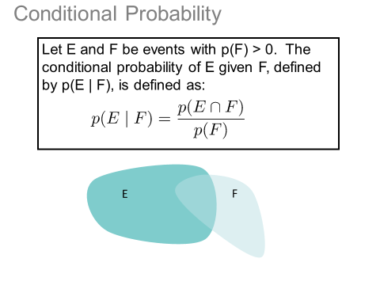Even with unfair/biased coins our combination rules still hold:

* 
* 

# Conditional probability

Sometimes we want to know what the probability is of something given some other fact. So, say for example say I want to know if my stiff neck is because I have meningitis.

1. Sample space: All combinations of choosing 5 cards out of 52 cards. |S| = C(52,5) = 2,598,960

   Event|E| = C(13, 1) C(48, 1) = 13\*48 = 624

   P(E) = |E|/|S| = 13\*48/ C(52,5) = 0.00024 [↑](#endnote-ref-2)