EECS 452 Midterm Closed book part
Winter 2010

Name: ____________________________________ unique name: _______________

Sign the honor code:

I have neither given nor received aid on this exam nor observed anyone else doing so.

___________________________________

Scores:
# | Points
Closed book
Page 2 | /11
Page 3 | /14
Open book
Page 2 | /15
Page 3 | /15
Page 4 | /15
Pages 5 and 6 | /18
Page 7 | /8
Page 8 | /4
Total | /100

NOTES:
- There are 3 pages including this one.
- On the closed book section you may not have books, notes, but you may have a calculator. Nothing but a writing utensil and calculator is allowed.
- Don’t spend too much time on any one problem.
- You have about 120 minutes for the exam. You probably shouldn’t spend more than 20-30 minutes of it on this section.
Closed book portion

- Say you took a 32-point DFT of the following signals with f_{s}=3200Hz starting at time t=0. What would be what the non-zero DFT outputs would be (magnitude and phase)?
[3 points each]
  - 2*sin(2 π *400t+ π)

  - 2*cos(2 π *800t- π/4) + 3

- Write the transfer function that corresponds to the following block diagram. [5 points]
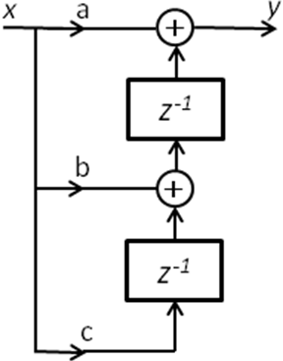

- Fill in the blank or circle the correct answer. Provide all numbers in decimal. [14 points, -1 per wrong or blank answer, minimum 0]
  - If we multiply a 16-bit Q15 value by a 16-bit Q10 value the result would be a ________-bit Q________ number.
  - An 8-bit unsigned number (Q-1) can exactly represent a value as small as 0 to as large as ________________.
  - Say you took an N-point DFT of a signal with a sample frequency of f_{s}. The
frequency spacing of the DFT outputs would be __________________

  - A 6-bit Q4 2’s complement number has a range from ___________ to _____________ and a resolution of _____________.
  - We say a filter is stable if what property holds? __________________________________________________________.

  - In 5-bit two’s complement Q3, what is the value of 11010? ____________________.
  - A traditional 16-point DFT requires about 12 / 32 / 128 / 256 / 420 / 3000 complex multiplications while the radix-2 algorithm discussed in class requires about
12 / 32 / 128 / 256 / 420 / 3000 complex multiplications.

  - All FIR filters with real-valued coefficients have linear phase / are stable /
are low-pass.
  - A waveform is sampled using a sample rate of 44 KHz. If you desire a frequency
spacing of 0.5 Hz in the DFT of the sample set, you’ll need ____________ samples.

  - A 100Hz sine wave has a period of ____________________ μs.

  - Say you have an ideal A to D converter which converts values from 16V to -16V to a
10-bit value. The worst-case quantization error is ±____________ Volts.

  - If a 16-point DFT of a given set of real-valued data has x(3)= 4 ∠ -120°, we know
that x(________) = _______________________

EECS 452 Midterm Open book part
Winter 2010

Name: ____________________________________ unique name: _______________

Sign the honor code:

I have neither given nor received aid on this exam nor observed anyone else doing so.

___________________________________

Scores:
# | Points
Open book
Page 2 | /18
Page 3 | /11
Page 4 | /16
Page 5 | /8
Page 6 and 7 | /20
Pages 8 | /10
Total | /100

NOTES:
- There are 10 pages including this one.
- On the open book section you may use calculators, books and notes, but no PDAs, Portables, Cell phones, etc.
- Don’t spend too much time on any one problem.
- You have about 120 minutes for the entire exam.
- Some questions are much harder than others…
- You’ve been asked to write C function “xmult()” for the C5510 which takes two signed 16-bit Q14 numbers and returns their product as a 16-bit number. The output shouldn’t overflow, should round to the closest number (break ties however you wish) and you must get the best resolution possible (You can also ignore the possibility of -2 times -2).
  - What Q value should you use for the answer? [3 points]
  - Write the C function xmult(). Remember it is for the C5510. [5 points]
- Say you have a band-limited signal with frequency centered at 18MHz with a bandwidth of 6MHz. What is the lowest frequency you could sample this signal at and (in theory) not lose any information? Show your work. [7 points]

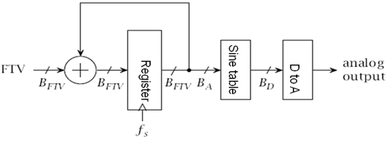
- JoeBlow Audio has hired you to build them a digital device which outputs a sine 500Hz sine wave which has a 2 Volt amplitude (it ranges from -2 to 2 Volts). They want the sine wave to never be more than 5mV different from an ideal (real number) sine wave with the same frequency and amplitude. You may assume you can get an output of exactly 500Hz.
After some thought, you’ve realized this seems fairly difficult because you will be introducing error due both to the time and amplitude quantization inherent in any DDS scheme. So you’ve decided not to let the time quantification cause more than a 3 mV error and the amplitude quantification cause more than a 2 mV error, thus insuring that there is no more than a 5mV error at any given point.
  - To achieve these goals, what is the minimum number of bits that must be in each entry of the sine table? Clearly show and explain your work. [7 points]

  - To achieve these goals, what is the minimum number of entries that must be in the sine table? Clearly show and explain your work. [8 points]

- It is known that the group delay of a given linear-phase filter is 0.02 seconds. Assuming the following frequencies are in the pass-band region, what would be the expected phase of each signal? Provide your answers in radians in the range of (-π to π] and show your work.
[6 points, 3 each]
  - 66Hz.
  - 1005Hz

- What is the main cause of spectral leakage? Give an example of when you won’t get leakage. [5 points]

- What is the main reason why IIR filters are implemented using biquad cascades? [4 points]
- Consider the following block diagram (The -1 means we are multiplying by -1).
  - Write the transfer function for the following block diagram. Show your work.
[7 points]

  - For what values of “a” is the transfer function stable? Explain your answer [3 points]

(7 continued)
  - Write a function, short trans (short x, short *w)which takes a single input x, and returns the y value. Assume a=2 and that the array w is used for as many z⁻¹ blocks and is of any fixed size you find useful. You may assume all inputs are in 16-bit Q15 and no overflow occurs. [8 points]

- Answer the following questions about the D2A converter shown

  - Assuming Vref=4V and R=2kΩ
    - If D[3:0]=1011, what is Iout? [3 points]
    - If D[3:0]=0110, what is Iout? [3 points]
  - If we were going to make a 16-bit converter using this R/2R ladder scheme, how many transistors would we need? [2 points]
- Consider the following plot. Draw lines showing how the zeros and poles would be paired into biquad sections [4 points]

