EECS 481 Winter 2004 Homework 3 KEY

100 points total

Object-Oriented Development
1. Which phases of the software lifecycle can be performed in an object-oriented fashion?
10 pts, 2.5 each
Requirements, design, coding, testing

2. Must object-oriented development be sequential? Why / why not?
5 pts
No – it depends on the software lifecycle model chosen

3. What special impact does object-oriented development have on the relationship between requirements and design?
5 pts
Because the requirements specification must identify objects and relationships, it often bears high similarity to the system design and for that reason is often omitted.

4. Why are use cases useful for determining requirements in an object-oriented software project? Why are they useful in determining the system design?
10 pts
They are useful for determining requirement because they can be understood by the customer and are abstract diagrams of what objects will be interacting in the system. They are useful during design because they identify the objects and interactions necessary to create a functional system.

5. What are the advantages of measuring the complexity of an object-oriented design?
10 pts
It can help guide the design and avoid poor design decisions, it is useful for predicting maintenance costs, etc.

Program Design and Coding
6. What are two advantages and disadvantages of using design patterns (Gamma et al.) in program design?
10 pts, 2.5 each
Advantages include: patterns have been used successfully in many different applications in the past, patterns are generally ‘correct’ design, patterns are in some sense the ‘reuse’ of design which is a difficult thing to reuse
Disadvantages include: patterns require a skilled programmer to implement, patterns may not apply completely to the given situation (or worse they may seem to apply completely but not actually apply completely)

7. You’ve written a significant amount of program code over the course of your life. What is one programming standard/guideline/practice you adhere to and why do you adhere to it? What is one example of a time where you wished you had adhered to a standard/guideline/practice that you didn’t?
10 pts
Any reasonable answer

UML questions 7-9, 10 pts each (note there is a typo and there are two #7’s in this homework)

Class Diagram:
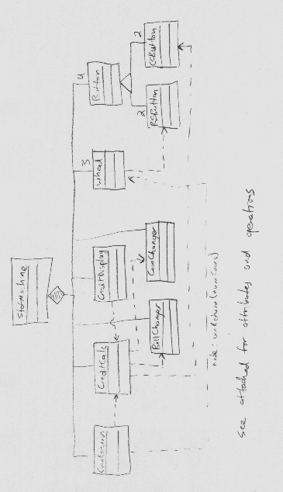

State Chart:
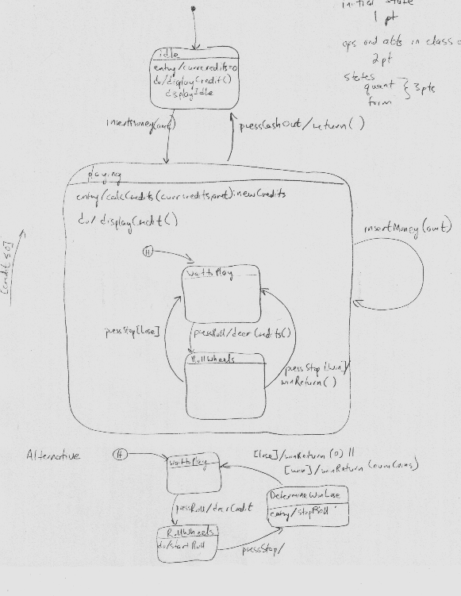

Use Case:

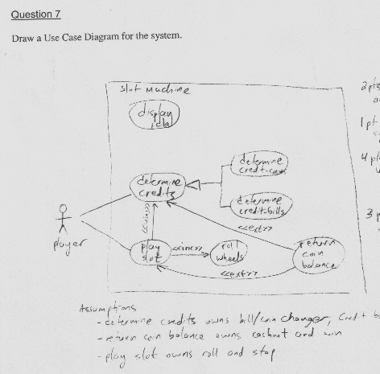

Portfolio Question: 10 pts

