More on datapath

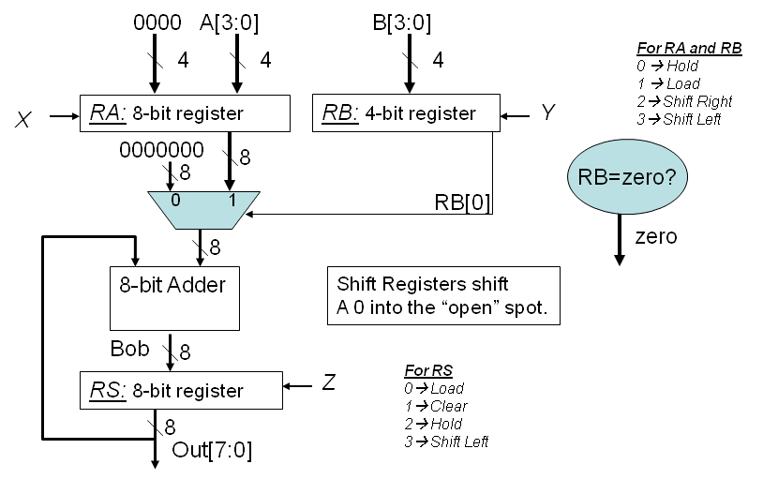

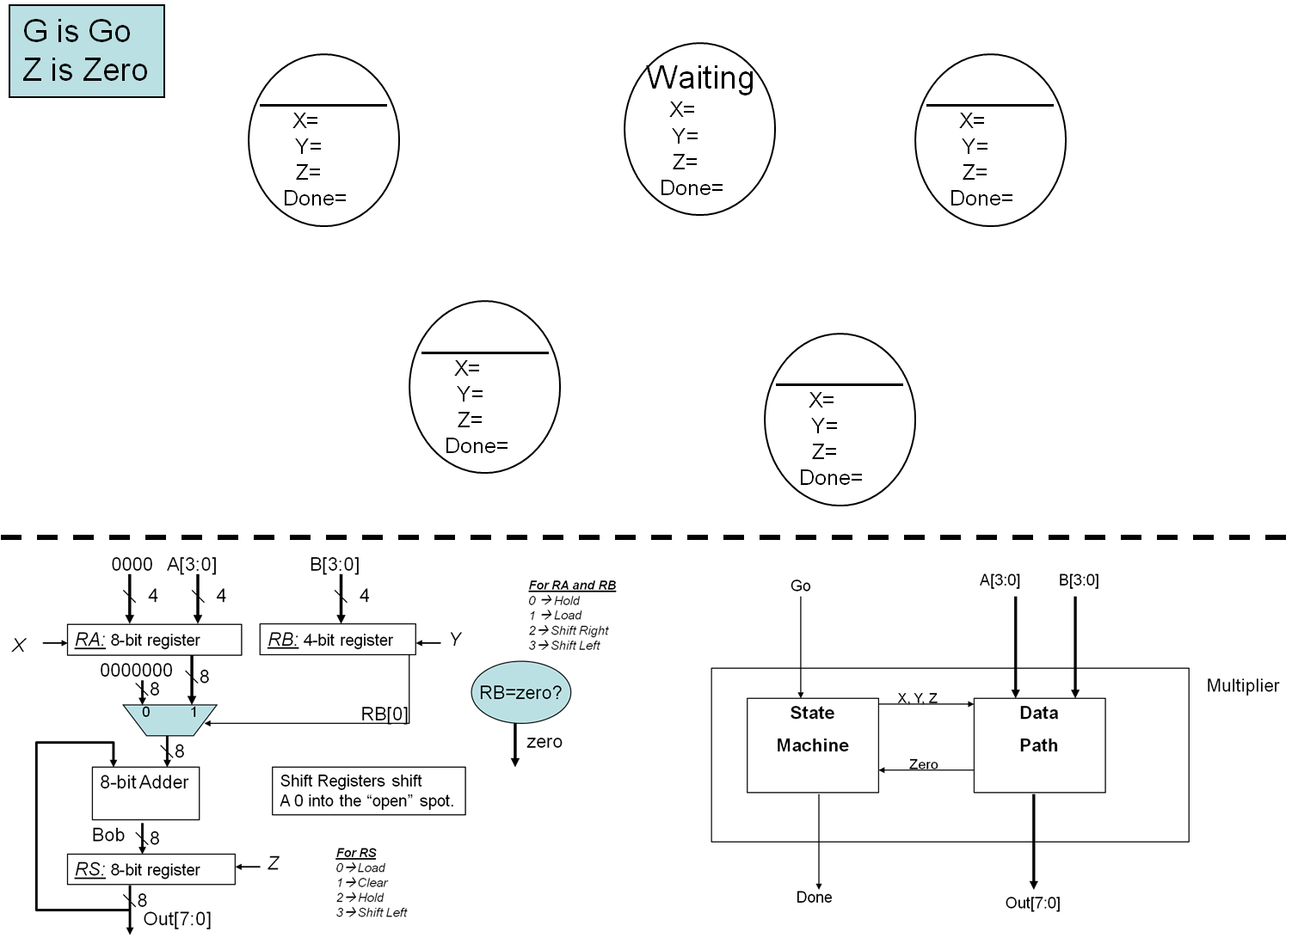

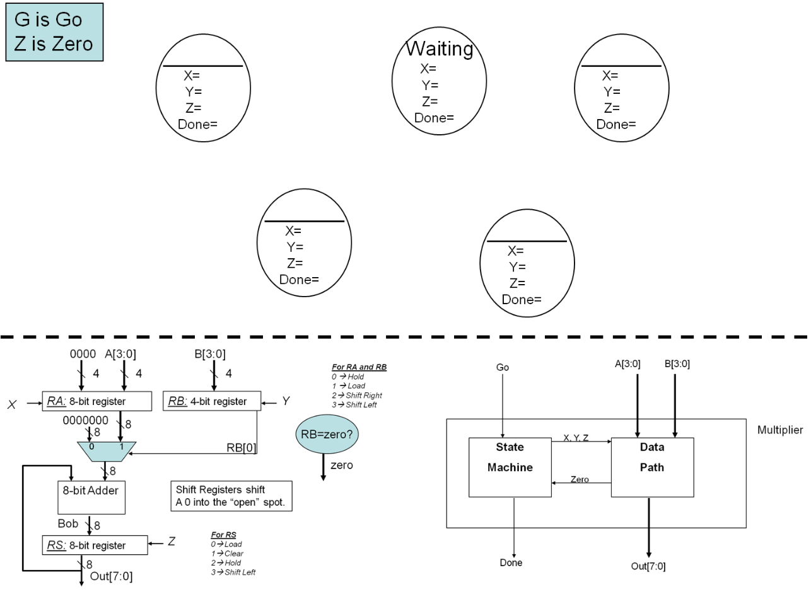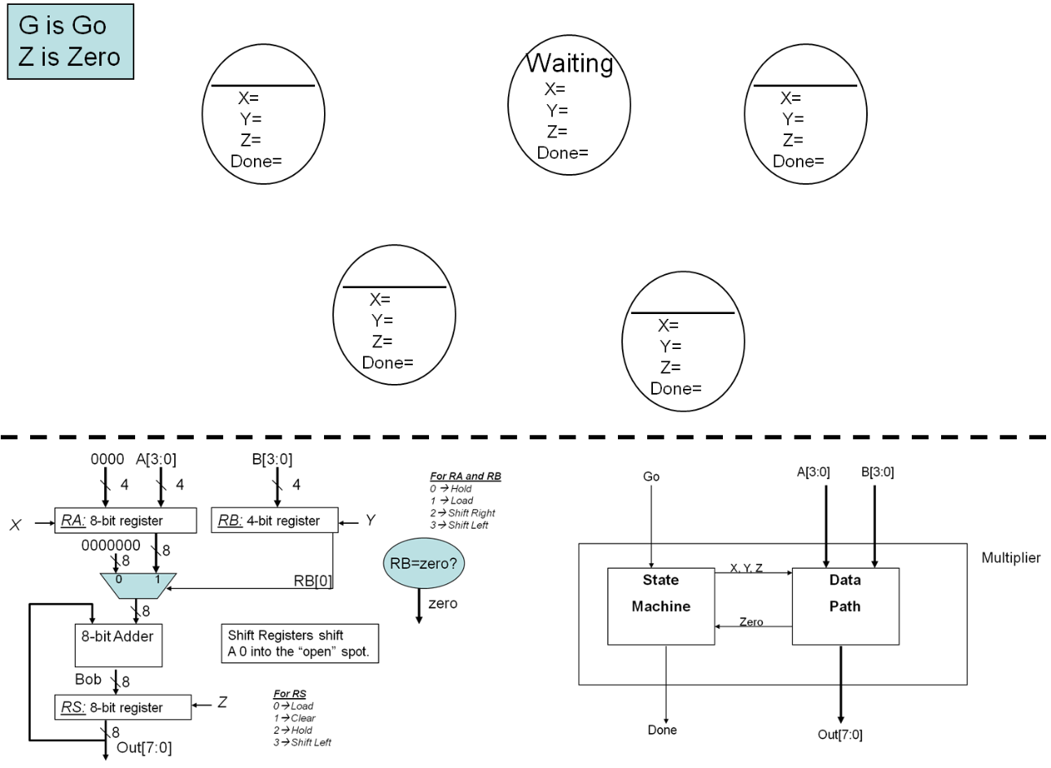

CLK

Go

X

Y

Z

Bob

RA

RB

RS

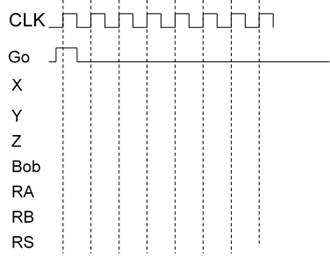





# Another example: laser distance sensor.

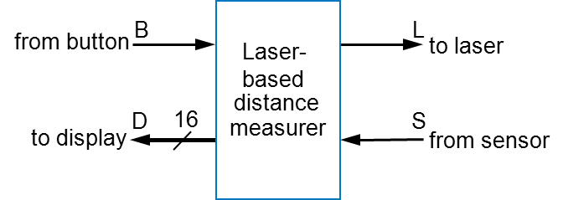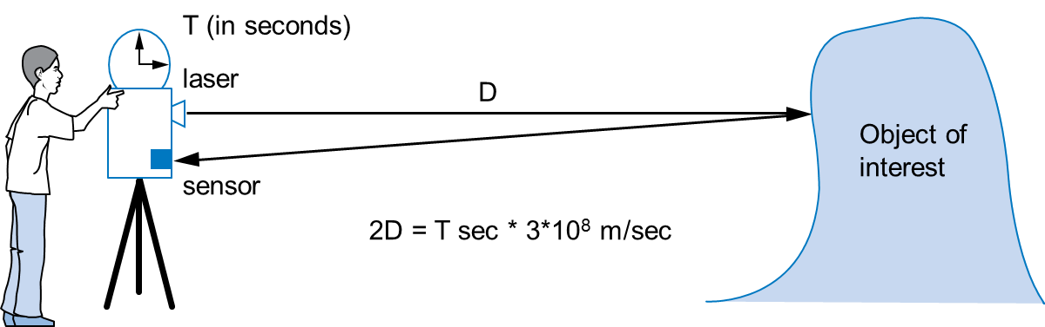

* Laser light travels at speed of light, 3*108 m/sec
* Distance is thus D = T sec * 3*108 m/sec / 2
* Inputs/outputs
  + ***B***: bit input, from button to begin measurement
  + ***L***: bit output, activates laser
  + ***S***: bit input, senses laser reflection
  + ***D***: 16-bit output, displays computed distance