# Memories (5.6)

A memory is a device that acts like a big array. You supply an index (called an address) and it supplies the data at that location. You can also write to a given address.

On the left is a 1024x8 memory. That is it has 1024 entries and each entry is 8 bits wide. If Write Enable (WE) is a 1, that means we want to write the value on the data lines into the memory location specified by the address (A) lines. If WE is a 0 and Output Enable (OE) is a 1 that means we want the data at location A to be put on the Data lines. If both WE and OE are zeros, Data is high-Z.

A[9:0]

OE Data[7:0]

WE

Clock

10

8

Notice that data is sometimes an input and sometimes an output!

Questions:

1. What values should we apply if we want to write 0x12 to memory location 0x044?  
     
    A[9:0]= __________ OE=______ WE=______ Data[7:0]=__________
2. What values should we apply if we want to read memory location 0x44?  
     
    A[9:0]= __________ OE=______ WE=______ Data[7:0]=__________

## Types of memories

There are a number of different types of memories each with a different set of *properties*.

* ROM: _______________________________________________________________________
* RAM: _______________________________________________________________________
* Volatile vs. Non-volatile: _________________________________________________________
* Static vs. Dynamic: _____________________________________________________________

And we commonly find the following common memory types:

* DRAM: ______________________________________________________________________
* SRAM: ______________________________________________________________________
* Flash*:______________________________________________________________________

*Note that flash is a particular technology. There are other things (e.g. Magnetoresistive RAM (MRAM)) that have similar properties.

## Inside the memories—the little picture

Memories are generally large arrays with small 1-bit cells in them. Let’s look at the cell in an SRAM[1] and DRAM[2].

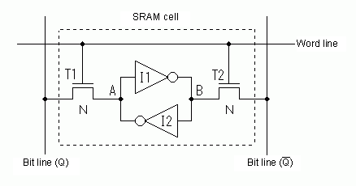On the left is a single SRAM cell. The inverter pair should be familiar to you—it’s the same bi-stable device we started with as a starting point for a latch. The other devices are transistors. We’ll cover them in a few weeks, but in this context you can basically think of them as being a door. If the word line is high, A connects to Q and B connects to Qbar. Otherwise they don’t. To read from the device, we simply set the word line high and read the bit line. To write, we “strongly” drive the bit lines and set the word line to be one. That will override the inverter pair’s relatively weak signal.

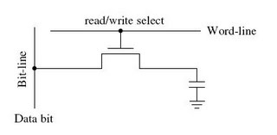

DRAM works in a very similar way. The main difference is that a capacitor is used to store the value. That capacitor will only hold the value for a short time (on the order of 1 to 10 ms!). (A capacitor is a device that holds a certain voltage level for a while). It also suffers from a feature called a “destructive read”—when you read the data, the data is lost.

To deal with the issues associated with the value going away on a DRAM we have to “refresh” the capacitor on a regular basis. That means we read and re-write the data many hundreds of times a second…

### SRAM vs. DRAM

Area/Density:

* You can generally put about 5-20 DRAM cells in place of one SRAM cell. This translates into DRAM being a lot cheaper per bit.

Cost:

* Cost tends to be fairly proportional to area…

Speed:

* SRAM tends to be a lot faster (say on the order of 1-3ns compared to 20-100ns for DRAM).

Power:

* SRAM tends to eat a lot more power (4GB of DRAM is around 10 Watts in one case, 4MB of SRAM is about 0.5 Watts in another, so a factor of 50/bit in this case. That’s not quite a fair comparison; a factor of 10 might be closer…)

We tend to use DRAM when we need lots of cheap memory. SRAM when we need to go fast. A microprocessor uses DRAM for the main memory and SRAM for the cache (small fast memory that keeps most likely to be needed data).

## Inside the memories—the big picture



The figure on the left shows how to use a 4x4 memory block to create a 16x1 memory (16 addresses, each one bit). In this diagram we have 4 address lines and one data line. There is also an OE’ (meaning active low) and a WE’ (also active low).

**Questions:**

1. What is the decoder doing?
2. What is the MUX doing?
3. What is CS’ doing?
4. Memory blocks tend to be square (4x4 in this case).

Why do you think that is?



1. Given a 16x16 memory array in which we want to have 4-bit words, how many different words would there be?
2. Fill in the five blanks found in the figure to the right.

1. Figure taken from necel.com.
2. Figure taken from 1.bp.blogspot.com